

Laser Systems Ltd.

**PULSED DOPPLER wind lidar**

**WINDEX-2000**

**SOFTWARE**

User Manual

Saint Petersburg

2017

**TABLE OF CONTENTS**

INTRODUCTION 3

1 PROGRAM OVERVIEW 4

1.1 Summary 4

1.2 Minimum hardware and software requirements 4

1.3 Program functions 5

2 PROGRAM INSTALLATION 6

3 PROGRAM OPERATION 7

3.1 Program startup 7

3.2 Program interface 7

3.3 Selecting scan modes 8

3.4 Adding/removing scan mode 9

3.5 Setting parameters of scan mode 9

3.5.1 Parameters of PPI mode 10

3.5.2 Parameters of RHI mode 10

3.5.3 Parameters of LOS mode 11

3.5.4 Parameters of DBS mode 11

3.6 Setting combined mode 12

3.7 Setting time period and time shift of scan start 12

3.8 Loading and saving scan templates 13

3.9 Starting/stopping measurings 13

3.10 Visualizing measurement results 14

3.10.1 Distributing wind parameters in horizontal plane 14

3.10.2 Vertical section 18

3.10.3 Changing radial speed in a set direction 18

3.10.4 Wind profile 20

3.10.5 Single measurement data 21

3.11 Loading and saving measurement results 22

3.12 Adjusting program settings 23

3.13 Closing program 25

# INTRODUCTION

This manual is intended as a guide to the functional capabilities of client software supplied with Pulsed Doppler Wind Lidar WINDEX-2000 (hereinafter referred to as WINDEX-2000) and describes the procedures at startup and during runtime of the program.

* *Chapter 1, Program overview*, contains a short description of the program and its main functions, hardware and software requirements for program functioning.
* *Chapter 2, Installing and removing program*, describes sequence of operations for installing the program.
* *Chapter 3, Operating the program*, describes sequence of operator’s operations to start, execute and close the program, possible commands for an operator to operate the program.

An operator shall have experience working on a Microsoft Windows OS-based computer at the level of a qualified user and easily fulfill basic operations in Microsoft Windows standard applications.

**Technical support**

Laser Systems Ltd.

34A, Svyazi Str, Strelna, St. Petersburg, 198515, Russia

phone (812) 612-02-88, fax (812) 777-78-30

E-mail: [office@lsystems.ru](mailto:office@lsystems.ru)

<http://www.lsystems.ru>

# PROGRAM OVERVIEW

## Summary

This software is intended for remote reading, processing and visualization of measurement results obtained by means of WINDEX-2000.

## Minimum hardware and software requirements

Hardware minimum requirements:

* IBM PC compatible computer with Intel i5 processor (2.6 GHz or more);
* 4 GB RAM or more;
* 512 MB NVIDIA VRAM or more;
* Ethernet interface;
* 250 GB HD or more.

Microsoft Windows 7 or a later version, Microsoft .NET Framework 4 (not older), Visual C ++ runtime components are required to be installed to ensure normal operation of the program.

## Program functions

The program performs the following main functions:

* setting (adjusting) of WINDEX-2000 scan modes and startup options;
* combining scanning modes in one template;
* creating and saving scan templates (operation cyclogram) for the device;
* storing measurement results;
* visualizing current data from WINDEX-2000 in text and graphic form in real-time;
* visualizing saved data from the database;
* displaying device status diagnostic information.

# PROGRAM INSTALLATION

In order to install the program run a setup file from the supplied CD and perform installation following instructions of the installation wizard.

# PROGRAM OPERATION

## Program startup

In order to start the program, simply hover over the shortcut icon on your desktop and double-click the left button. It will display the main program window (Figure 1).

## Program interface

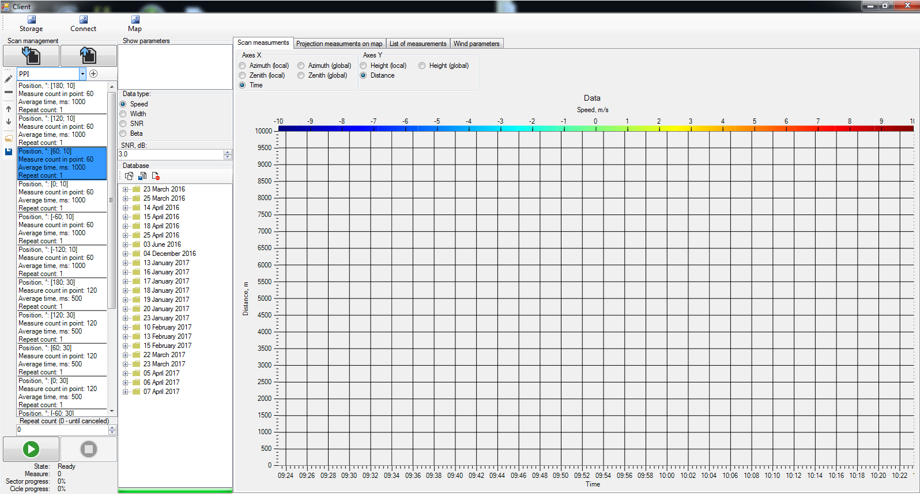

Figure 1 Main program window

## Selecting scan modes

Depending on required parameters of wind, the program allows you to set various scan modes (PPI, RHI, LOS, DBS) (Table 1) or combine these modes according to your needs.

Table 1 - Scan modes

| Mode | Description | Result |
| --- | --- | --- |
| PPI  (Plan Position Indicator) | This is a circular scanning mode with a fixed elevation angle,  while an azimuth angle varies either throughout the whole range or in the selected sector. | Radial wind speed distribution map in a horizontal plane |
| RHI  (Range Height Indicator) | This is a mode where an azimuth angle remains constant, while an elevation angle varies in a certain range (vertical section). | Radial speeds distribution for a sector by height |
| LOS  (line-of-sight) | Time scanning with fixed azimuth and elevation angles | Radial speeds distance distribution in time |
| DBS  (Doppler Beam Swinging) | This mode is intended for measuring a vertical profile of wind (three point measuring) | Height distribution of wind direction and horizontal/vertical speed components |

|  |  |  |
| --- | --- | --- |
| In order to choose a scan mode, select an appropriate drop-down menu item (Figure 2). You can set a period and time shift of measurements start for each mode listed above using the drop-down menu item "Time Trigger" |  | Figure 2 Choosing a mode |

## Adding/removing scan mode

In order to add the selected scan mode, click button. It will display "Sector editor" window (Figures 3-6) allowing you to configure parameters of a scan mode.

In order to remove a scan mode, hover over a mode to delete (displayed in cyclogram area) and click button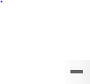.

In order to edit mode parameters, hover over a mode to configure (displayed in cyclogram area) and click buttonОписание: C:\Users\Mikhaylova\Documents\ARBEIT\СМЕНА ДСВ\ПД\17304 ОПО\Скриншоты\Скриншоты\Редактировать режим.PNG. This will display "Sector editor" window where you can set necessary parameter values.

## Setting parameters of scan mode

Clicking buttons  or  will display "Sector editor" window (Figures 3-6) where you can configure scan parameters of the selected mode. After setting necessary mode parameters, press button "OK".

### Parameters of PPI mode

|  |  |
| --- | --- |
| * average time, ms * begin azimuth angle, ° * channel mask (default value - 0) * end azimuth angle, ° * repeat count * scan speed, °/s * zenith angle, ° | Figure 3 Setting parameters of PPI mode |

### Parameters of RHI mode

|  |  |
| --- | --- |
| * average time, ms * azimuth angle, ° * begin zenith angle, ° * channel mask (default value - 0) * end zenith angle, ° * repeat count * scan speed, °/s | Figure 4 Setting parameters of RHI mode |

### Parameters of LOS mode

|  |  |
| --- | --- |
| * average time, ms * azimuth angle, ° * channel mask (default value - 0) * measure count in point * repeat count * zenith angle, ° | Figure 5 Setting parameters of LOS mode |

### Parameters of DBS mode

|  |  |
| --- | --- |
| * average time, ms * channel mask * measure count in point * points count * repeat count * vertical mode   (scan with a fourth upward-directed additional point: True – ON, False – OFF)   * zenith angle, ° | Figure 6 Setting parameters of DBS mode |

## Setting combined mode

|  |  |
| --- | --- |
| The program allows to combine several main modes in one template. In order to add any of the main scan modes to a combined mode, click button. In order to remove a mode, click button.  The type of a newly-added mode and scan parameters will be displayed in a special panel (Figure 7). | Figure. 7 Combination of modes |

Buttons andare intended for scrolling up/down within the list of scan modes, wherein the selected scan mode is highlighted in blue.

## Setting time period and time shift of scan start

You can set a period and time shift of scan start for any scan mode. To set a period and time shift, select "Time Trigger" menu item from a dropdown menu in the main window (Figure 2) and click button. After this, select and add a scan mode to apply the settings of a period and time shift.

|  |  |
| --- | --- |
| When setting a time value in "EventOffset" field, measurement takes place at those moments of time which are multiple of the set value.  When setting a time value in "EventOffset" field, a time shift of scan start in accordance with the set value will be activated. | Figure 8 Setting period and time shift |

## Loading and saving scan templates

In order to save a scan template (cyclogram) in the database, click button Описание: Описание: C:\Users\Mikhaylova\Documents\ARBEIT\СМЕНА ДСВ\ПД\17304 ОПО\Скриншоты\сохранить шаблон.JPG.

In order to pull a saved scan template (cyclogram) from the database, click buttonОписание: Описание: C:\Users\Mikhaylova\Documents\ARBEIT\СМЕНА ДСВ\ПД\17304 ОПО\Скриншоты\открыть шаблон.JPG.

## Starting/stopping measurings

Setting the repeat count of a scan mode is carried out using control keys  in "Repeat count" field. Value 0 means that scanning will be carried out until a forced stop.

In order to start measuring, press button . This will display scan results in real-time.

|  |  |
| --- | --- |
| Scan progress data is displayed at the bottom of the main window (Figure 9). It includes information about measurement status, completed measurement count, sector progress and cyclogram progress. | Figure 9 Scan progress |

To stop measuring click button C:\Users\Mikhaylova\Documents\ARBEIT\СМЕНА ДСВ\ПД\17304 ОПО\Скриншоты\Скриншоты\кнопка стоп.PNG.

## Visualizing measurement results

### Distributing wind parameters in horizontal plane

|  |  |
| --- | --- |
| Using an appropriate radio button in "Data type" panel in the main window (Figure 10), you can check the following scan results for PPI mode: radial speed distribution, spectrum width, signal/noise ratio (SNR) and reflectivity. | Figure 10 Choosing data to display |

In order to check distribution maps (charts) of these parameters in a horizontal plane in expanded view, choose "Scan measurements" tab; for a circular diagram, choose "Projection measurements on map" tab (Figure 11).

Figure 11-14 show circular scan results view.

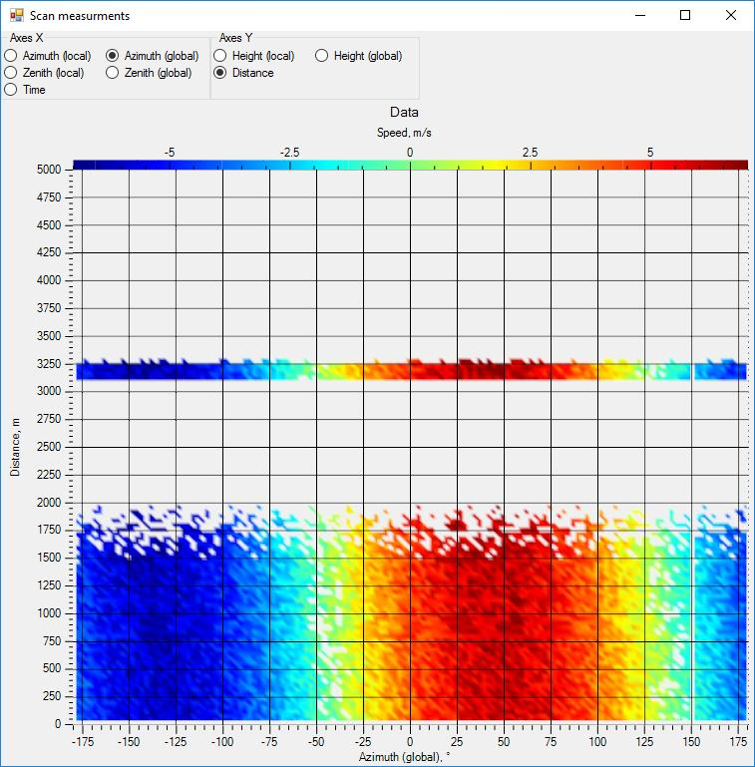

Expanded view

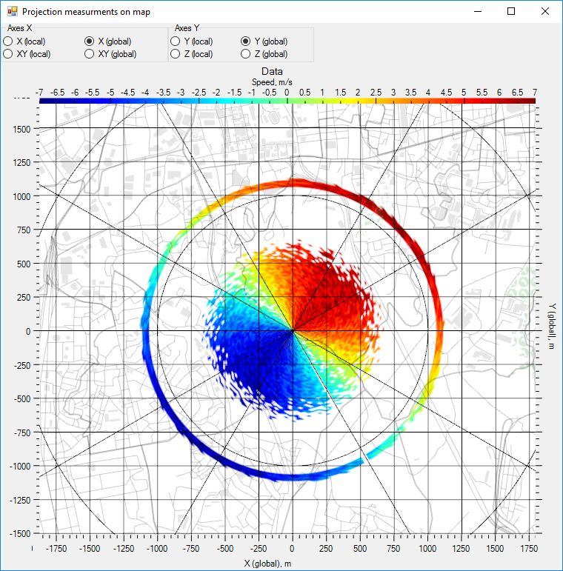

Circular view

Figure 11Wind speed distribution map

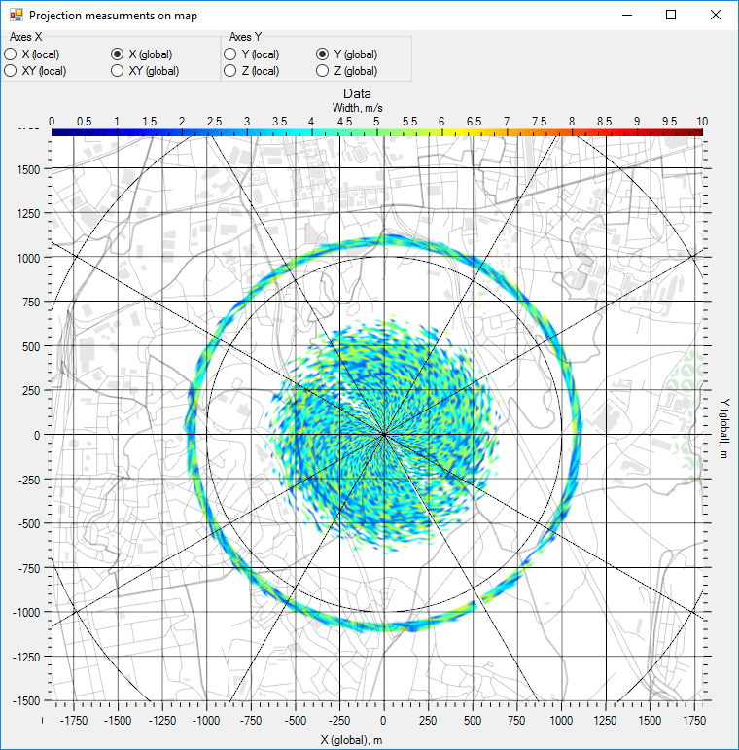

Figure 12 Spectrum width

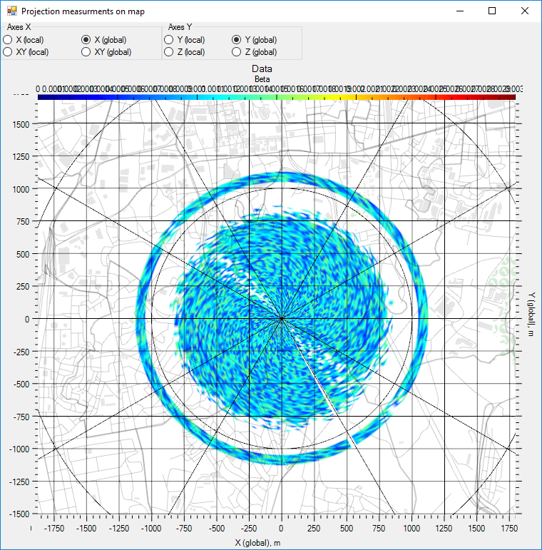

Figure 13 Reflectivity

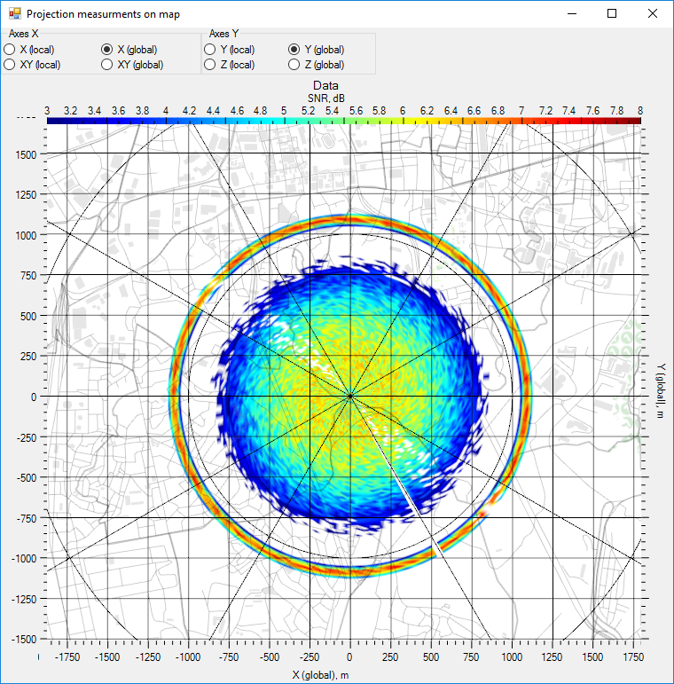

Figure 14 SNR

The color of diagram points corresponds to the measured values of parameters, while their location shows measurement distance (or height), XYZ coordinates of measurement points, polar coordinates of measurement points according to the zenith and local coordinate systems in respect of the device. Use the radio buttons in the tab area to configure display settings on the bottom horizontal and vertical scales.

### 

### Vertical section

The RHI scan mode allows to check the following results: radial speed distribution, spectrum width, signal/noise ratio (SNR) and reflectivity in a sector by heights.

You can also use "Scan measurements" tab to access height parameter distribution maps (charts) for a sector in expanded view; for circular view, use "Projection measurements on map" tab.

Figure 15 shows scan results view in RHI mode.

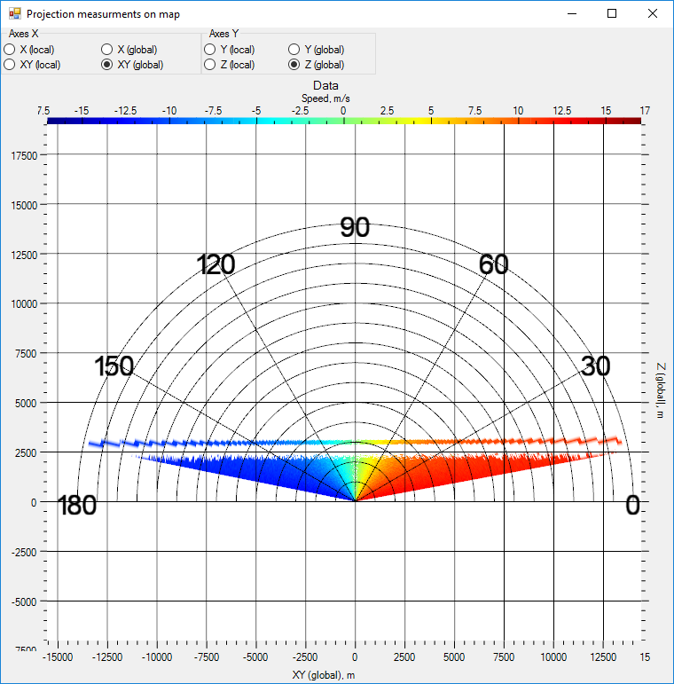

Figure 15 Radial wind speed distribution (circular view)

### Changing radial speed in a set direction

The information on radial speed change in a set direction (LOS mode operation result) is shown in "Scan measurements" tab.

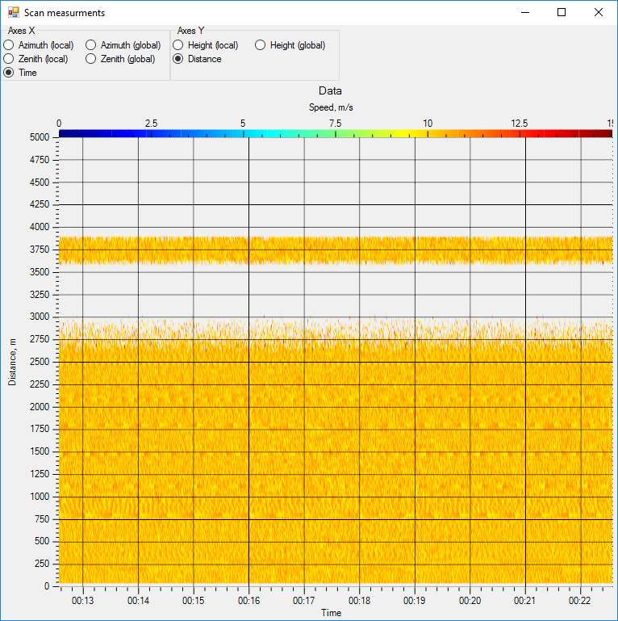

Figure 16 LOS mode scan result

### Wind profile

In order to view wind profile (DBS mode operation result), go to "Wind parameters" tab (Figure 17).

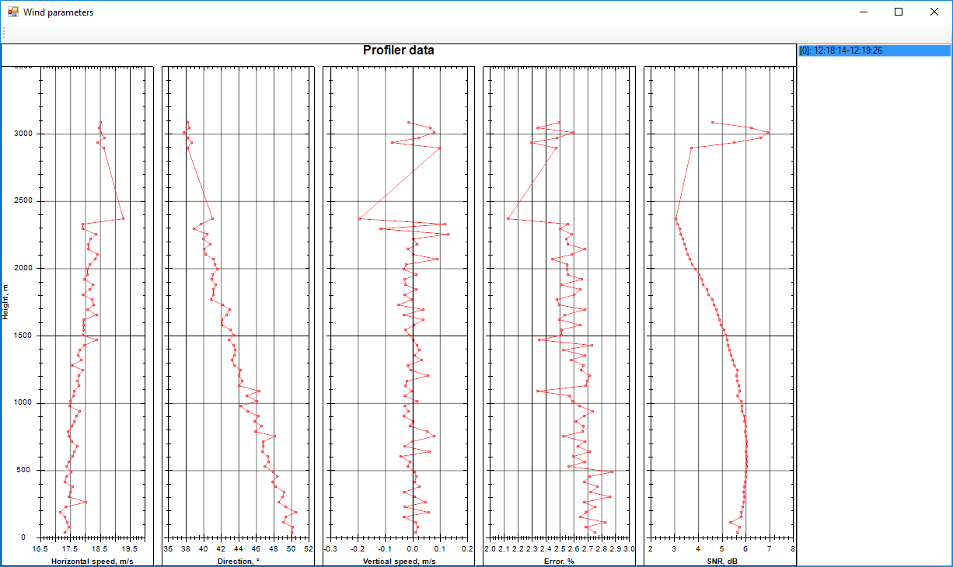

Figure 17 Wind profile

The tab shows the following measurement results:

* diagram of wind speed horizontal component distribution by scan height;
* diagram of wind direction distribution by height;
* diagram of wind speed vertical component distribution by height;

### Single measurement data

The program allows to view single measurement data for any mode in text and graphic forms in "List of measurements" tab (Figure 18).

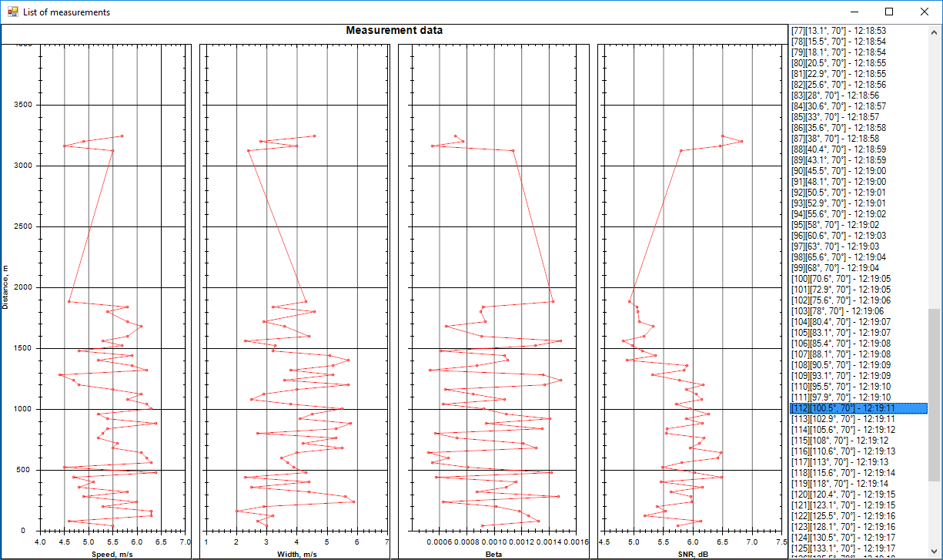

Figure 18 Single measurement data

The text view shows a measurement number, measurement point coordinates and the time of the measurement.

## Loading and saving measurement results

|  |  |
| --- | --- |
| After a scan cycle is completed, measurement results are automatically saved and displayed on a panel as a directory tree (Figure 19). The results are sorted by measurement date.  In order to view the previously saved data, double-click the required directory and select a measurement results file.  In order to add measurement results from the database, click buttonC:\Users\Mikhaylova\Documents\ARBEIT\СМЕНА ДСВ\ПД\17304 ОПО\Скриншоты\копировать результат.JPG.  In order to save measurement results in the database, click buttonC:\Users\Mikhaylova\Documents\ARBEIT\СМЕНА ДСВ\ПД\17304 ОПО\Скриншоты\сохранить результат.JPG.  In order to remove measurement results from the database, click buttonC:\Users\Mikhaylova\Documents\ARBEIT\СМЕНА ДСВ\ПД\17304 ОПО\Скриншоты\удалить результат.JPG. | Figure 19 Measurements database |

## Adjusting program settings

Program settings are adjusted in the main menu.

A user can adjust the following settings:

* adjusting the save path of measurement results file in the database;
* adjusting server connection and program operation parameters;
* adjusting the current map.

Select "Storage" menu item to set the file save path. It will display a window (Figure 20) with default file save parameters.

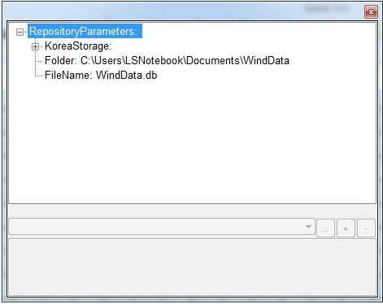

Figure 20 Adjusting file save parameters

Select "Connect" menu item to adjust server connection and program operation parameters. It will display a window for adjusting the required parameters (Figure 21).

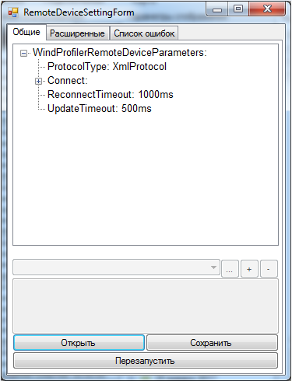

Figure 21 Adjusting connection and operating parameters

Select "Map" menu item to adjust the current map. It will display a window for setting location latitude and longitude, turning on/off map display and adjusting map transparency.

Use this window to add map object types: roads, houses, vegetation, etc.

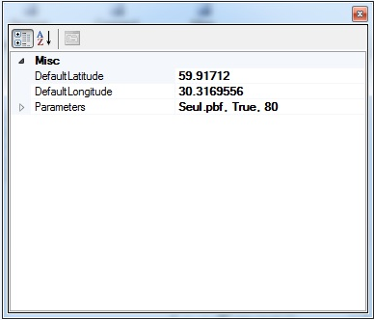

Figure 22 Adjusting the current map

## Closing program

In order to close the program (i. e. close all program windows), click button .